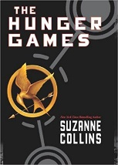
THE HUNGER GAMES – Letter Home
NAME:____________________________________Date Assigned:______________Date Due:_____________

Dear Families,
Your child will be getting a brand new copy of the book, The Hunger Games by Suzanne Collins. This will be an 8-week unit and will require support at home. We will be spending a lot of class time reading and analyzing the novel. However, they must also read at home. Keep a look out for important dates in agenda books and on my website. A final project letter will be coming home soon. The final project is done ALL AT HOME. They can do it with one partner or by themselves. They need to choose wisely as they need to be able to get together outside of school. Also, if they choose a project that requires a computer or printer, it must be available at home.
The book will need to be replaced if it is damaged or lost. It costs around $10.00 on Amazon. Please encourage your child to be careful with it and bring it to school every day.
Thank you for your support.

Cut and return
--------------------------------------------------------------------------------------------------------------------------------------------------
____I have read the above and am aware of The Hunger Games Unit, project and book. I also am aware that I must replace the book if it is lost or damaged.

_____________________________ ________________________________
Parent/Guardian Signature Student Signature

