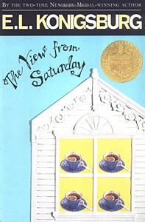

Date

Dear Parents and Guardians,

Your child received a copy of A View from Saturday by E.L. Konigsburg on ______________. They will have some time in school to read it, but they must also read it at home nightly. The first quiz is on ______________ and it will include chapters 1 – 3, up to page 93. There will be book report in the form of an award certificate and a final quiz. This will be due on ____________. The book report information will be sent home soon.

Thank You,
Mrs. LeClair

Cut and return the bottom
------------------------------------------------------------------------------------------------------------------------------------------
I understand that I have a copy of A View from Saturday and am responsible for the loss or damage of the book ($6.99) as well as a book report and other activities that go along with reading it.
_____________________________________ ______________________________________
Student Signature Parent Signature

